**STEPS TO CONFIGURE AND INSTALL IMU**

STEP 1: CHANGING ALL THE HLQ TO DESIRED PATHS.

Different HLQ in different clients, thus below is the solution.

Copy the modules below AND not touch original product.

IMU.V510.SFSYCCLC🡺 IMU.SFSYCCLC

IMU.V510.SFSYCCLM🡺 IMU.SFSYCCLM

IMU.V510.SFSYDOCS🡺 IMU.SFSYDOCS

IMU.V510.SFSYEZTC🡺 IMU.SFSYEZTC

IMU.V510.SFSYEZTS🡺 IMU.SFSYEZTS

IMU.V510.SFSYFJCC🡺 IMU.SFSYFJCC

IMU.V510.SFSYINST🡺 IMU.SFSYINST

IMU.V510.SFSYJCLS🡺 IMU.SFSYJCLS

IMU.V510.SFSYLOAD🡺 IMU.SFSYLOAD

Go into the dataset IMU.SFSYLOAD(FSYPROCS) to look for the HLQ.

Go into the dataset IMU.SFSYEZTS(FSYPROCS) and edit the like number 23 into the HLQ AND change line number 32.

PROCLIB0 DC C’DSN=FSOFT01.V4R1M0.SFSYJCLS(#EZTPROC)’

* PROCLIB0 DC C’DSN=IMU.SFSYJCLS(#EZTPROC)

PRODUCT0 DC C’SYS1=FSOFT01.V4R1M0’

* PRODUCT0 DC C’SYS1=IMU’

Then go into IMU.SFSYJCLS(JCASMBAS) AND make changes at line 43, then SUBMIT this batch job.

SET NEWSYS=FSOFT01.V4R1M0

* SET NEWSYS=IMU

Just to recheck, you can go back to the dataset IMU.SFSYLOAD(FSYPROCS) to check the HLQ.

**Step 1: in dataset “IMU.SFSYJCLS(#EZTPROC)” put a comment on the line in figure 1.**

Figure 1: Commenting the line in #EZTPROC



Figure 2: Commented line in #EZTPROC

**Step 2: Change the DB2 library to the one that client is using.**

Figure 3: Changing the DB2 library to client’s library

**Step 3: Comment out “IMSRLIB=IMS.V6R1M0.RESLIB(DFSLI000)”.**



Figure 4: Commenting out the line.



Figure 5: Commented out the line.

**Step 4: If the COBOL version is 5 and above, remove the “,LIB” like in figure 7. If the COBOL version is 4 and below, don’t change anything like figure 6.**



Figure 6: Example of what to do if COBOL version 4 and below.



Figure 7: Example of what to do if COBOL Version 5 and above.

**Step 5: Add in “SYSUT#” until “SYSUT15” because COBOL version 5 and 6 normally use until “SYSUT15”.**

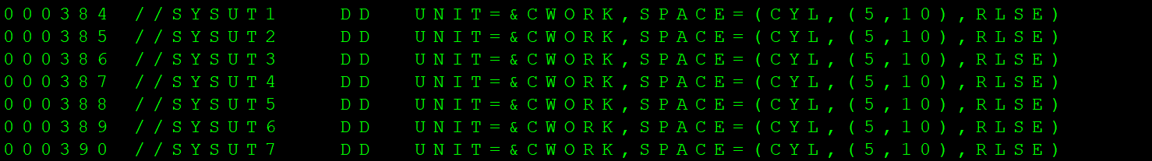

Figure 8: Before adding in SYSUT.

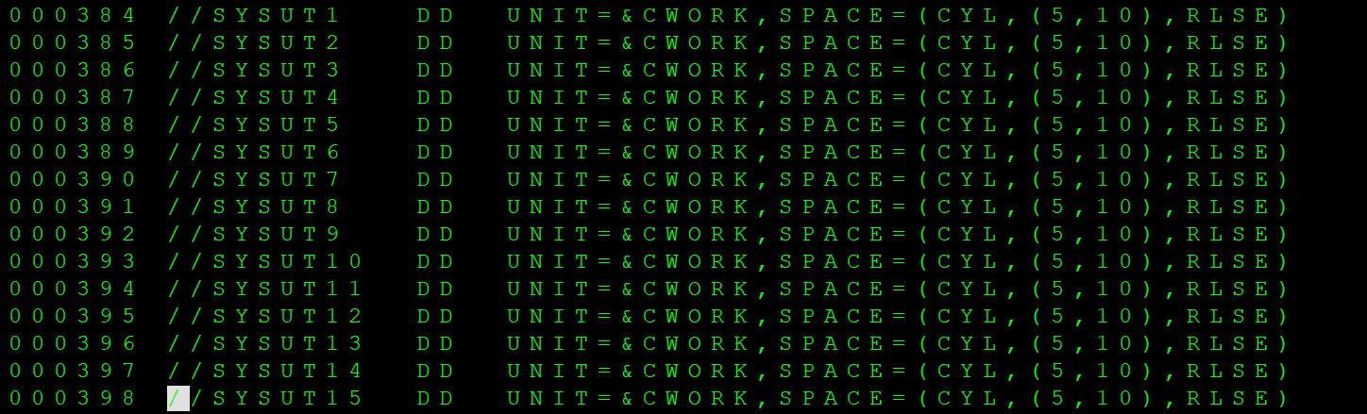

Figure 9: After adding in 12 more SYSUTs.

**Step 6: Add in extra lines below the SYSUT15 shown in figure 10.**



Figure 10: Adding in 5 lines.

**Step 7: Comment out LKED step as shown in figure below.**

Figure 11: Before commenting out the 4 lines.



Figure 12: After commenting out the 4 lines.

**Step 8: Change the variable name to IBMCOB in the same file.**



Figure 13: Before change of variable name



Figure 14: After changing the name to IBMCOB

**Step 9: Go into dataset IMU.SFSYEZTS and FSYPROCS member and change the PROCLIB0 and change the directory to “IMU.SFSYJCLS(#EZTPROC)”.**



Figure 15: Before changing directory.



Figure 16: After changing directory to the correct path.

**Step 10: In the same member, change the “FSOFT01.V5R1M0” to “IMU”.**



Figure 17: Before changing line 0032



Figure 18: After changing to “SYS1=IMU”

**Step 11: Go to “IMU.SFSYJCLS” dataset and open the member “JCASMBAS” to change “TSOUSR1.V5R1M0” to “IMU”.**



Figure 19: before changing “TSOUSR1.V5R1M0”



Figure 20: After changing to “IMU”

**Step 12: Run the batch job “IMU.SFSYJCLS(JCASMBAS)”**



Figure 21: Running JCASMBAS

**Step 13: Go to “IMU.SFSYCCLC” dataset and “FSYIVTAB” member and make sure all conditions are typed as “YES”.**



Figure 22: First condition.



Figure 23: Second condition.

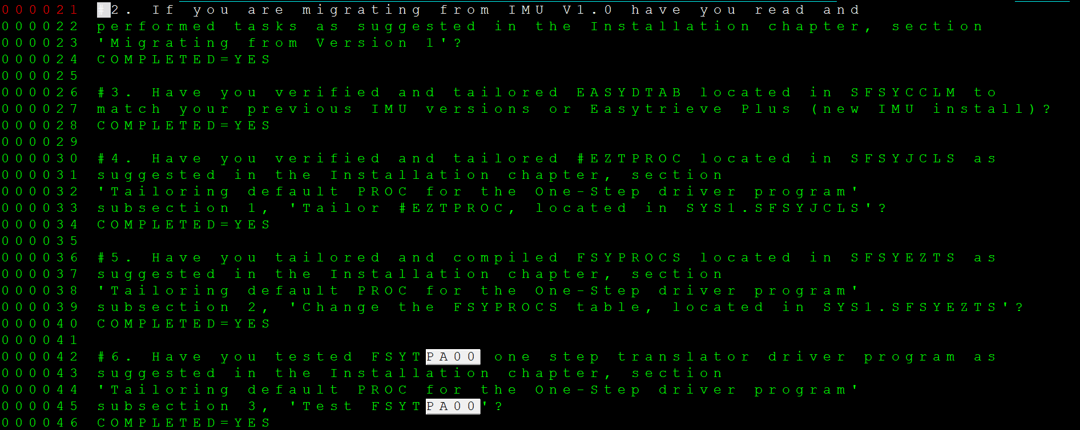

Figure 24: 2nd until 6th conditions.

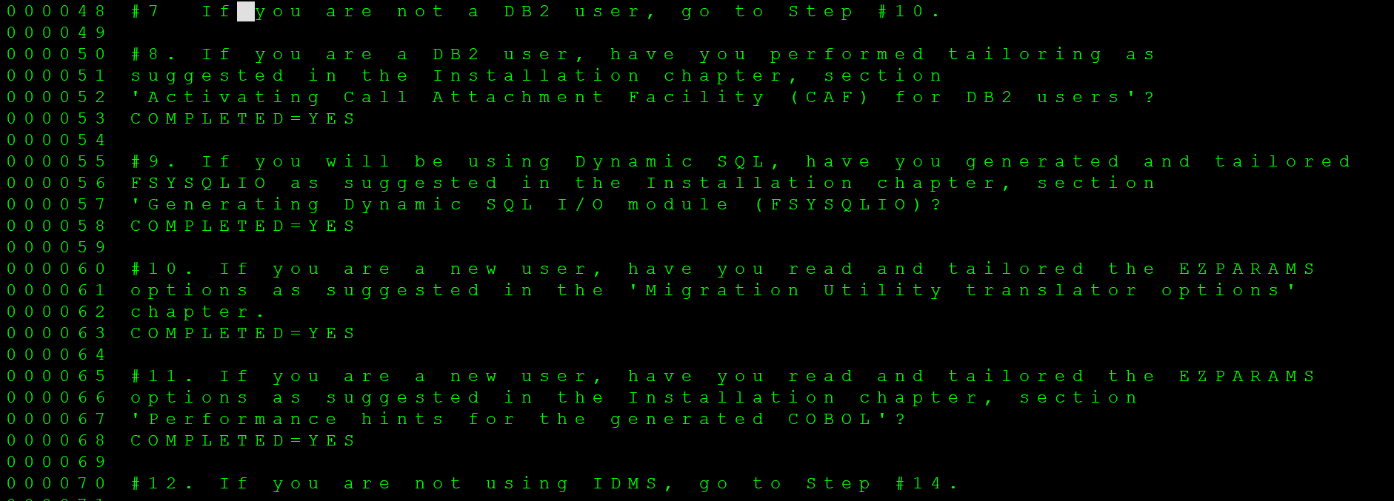

Figure 25: 7th until 12th conditions.

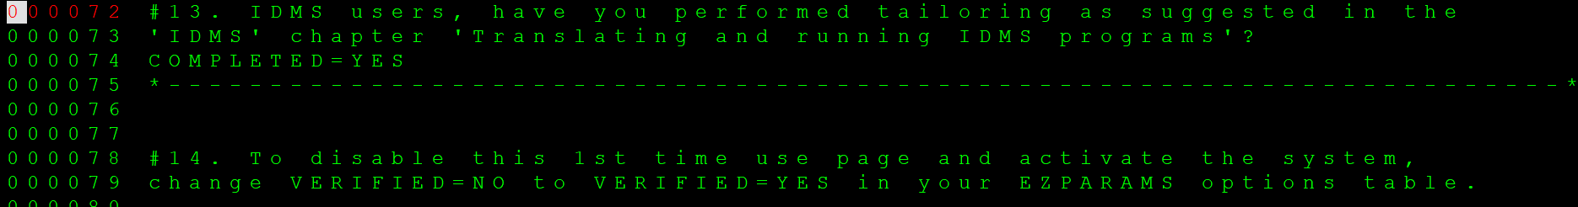

Figure 26: 13th and 14th conditions.

**Step 14: Go into “IMU.SFSYEZTS” dataset and go into “EZPARAMS” member. Since CPF is using a z14 machine, change the line 0002 to “PROCESS ADV,FASTSRT,OPT(2),ARCH(12)”. If another client is using a z15 machine, we would use “PROCESS ADV,FASTSRT,OPT(2),ARCH(13)” on the line 0002.**



Figure 27: Changing some of the parameters of member “EZPARAMS”.

**Step 15: Ensure line 0083 is “VERIFIED=YES” to let the program to check the system first.**



Figure 28: Ensuring the “NO” is changed to “YES”.

**Step 16: Find the parameter “NAMETAB” and change the element to ‘$S/-+A#N@V*-_-%P?Q.-&-‘.**



Figure 29: Changing elements.

**Step 17: Find “ETBROWS” and change the default value (512) to “999”.**



Figure 30: Changing the value from 512 to 999.

**Step 18: Find “BLANKFIX” and change the value to “NO”.**



Figure 31: Changed value to “NO”

**Step 19: Find “PRINTIO” and input “,,,EXPCC” into the bracket like in Figure 32.**

Figure 32: Inputting values into the PRINTIO parameter.

**Step 20: Go into “IMU.SFSYCCLM” dataset and go into the “EASYDTAB” member. Look for “ACCL SETVM”, then change the date format to “DDMMYY” at line 0123.** 

Figure 33: Before changing the date format to Day/Month/Year.



Figure 34: After changing the date format to Day/Month/Year.

**Step 21: Look for “ACCT SERVM &GDATLFORM,MMDDCCYY” and change it to “ACCT SERVM &GDATLFORM,DDMMCCYY”.**



Figure 35: Before changing the date format.



Figure 36: After changing the date format.

**Step 22: Look for “DTLCTL” keyword and ensure the following parameter in Figure 37 is listed as “FIRST”.**



Figure 37: Ensuring the “FIRST” keyword is correct.

**Step 23: Go into the dataset “IMU.SFSYEZTS” and look for “EZPARAMS” member. Then look for the keyword “COBOL” and ensure the value is “Z/OS”.** 

Figure 38: Ensuring the value of “COBOL” is “Z/OS”.

**Step 24: Go back to the “EASYDTAB” member and look for the keyword “LINESIZE” and ensure the value is “132”.**



Figure 39: Ensuring value of “LINESIZE” is “132”.

**Step 25: Look for the “GDATESIZE” parameter at line 0119 to ensure the value is “SHORT”.**



Figure 40: Ensuring the value is “SHORT”.

**Step 26: Go back to the “FSY410.SFSYETS” dataset and in the “EZPARAMS” members, look for keyword “CURRENCY” to change the currency.**



Figure 41: Ensuring the Currency value is correct

**Step 27: In the same dataset as step 26, look for keyword “DECIMAL” and ensure it is “PERIOD”.**



Figure 42: Ensuring the “DECIMAL” value is “PERIOD”

**Step 28: In the same dataset as step 26, look for keyword “SORTWORK” and ensure the value is “3”.** 

Figure 43: Ensuring “SORTWORK” value is “3”

**Step 29: Go back to dataset “FSY410.SFSYCCLM” in the “EASYDTAB” member, ensure the** **&GPAGESIZE parameter is set to the value of “58”.**



Figure 44: Ensuring “&GPAGESIZE” parameter is “58”.

**Step 30: In the same member, also look for “&GPAGEWORD” parameter and ensure it is set to “PAGE”**



Figure 45: Ensuring “&GPAGEWORD” is set to “PAGE”.

**Step 31: Go back to dataset “FSY410.SFSYEZTS” in the “EZPARAMS” member, ensure the “ENDCOL” parameter’s value is “72”.**



Figure 46: Ensuring “ENDCOL” parameter is “72”.

**Step 32: Go back to the dataset “FSY410.SFSYCCLM” in the “EASYDTAB” member, ensure the “&GDATSMASK” parameter’s value is 99/99/99.**



Figure 47: Ensuring “&GDATSMASK” value is 99/99/99.

**Step 33: In the same member, look for “&GDATLMASK” parameter and ensure the value is “99/99/9999”.**



Figure 48: Ensuring “&GDATLMASK” parameter is “99/99/9999”.

**Step 34: In the same member, look for “&GSYSTIMEC” parameter and ensure the value is ‘.’.**

  
Figure 49: Ensuring “&GSYSTIMEC” parameter value is ‘.’.

**Step 35: In the same member, look for “&GSKIP” parameter and ensure the value is “0”.**



Figure 50: Ensuring “&GSKIP” parameter value is “0”.

**Step 36: Go back to dataset “FSY410.SFSYEZTS” in the “EZPARAMS” member, and look for parameter “WRKSPACE” and ensure the value is '(CYL,(10,50),RLSE),UNIT=SYSDA', in IMU.SFSYEZTS(EZPARAMS).**



Figure 51: Ensuring “WRKSPACE” parameter is '(CYL,(10,50),RLSE),UNIT=SYSDA', in IMU.SFSYEZTS(EZPARAMS)

**Step 37: Go back to the dataset “FSY410.SFSYCCLM” in the “EASYDTAB” member, ensure the “&GSPACE” parameter’s value is “3”.**



Figure 52: Ensuring “&GSPACE” parameter’s value is “3”.

**Step 38: In the same member, look for parameter “&GSPREAD” and ensure the value is “0”.**



Figure 53: Ensuring “&GSPREAD” parameter’s value is “0”.

**Step 39: Go back to dataset “FSY410.SFSYEZTS” in the “EZPARAMS” member, and look for parameter “CAFSSID” and ensure the value is “(DBP2)” or accordingly to the client’s system.**



Figure 54: Ensuring “CAFSSID” parameter is assigned to customer’s machine.

**Step 40: Go back to the dataset “FSY410.SFSYCCLM” in the “EASYDTAB” member, ensure the “&GSUMCTL” parameter’s value is “HIAR”.**



Figure 55: Ensuring “&GSUMCTL” parameter’s value is “HIAR”.

**Step 41: In the same member, look for “&GSUMSPACE” parameter and ensure the value is “3”.**



Figure 56: Ensuring “&GSUMSPACE” parameter’s value is “3”.

**Step 42: In the same member, look for “&GTALLYSIZE” parameter and ensure the value is “2”.**



Figure 57: Ensuring “&GTALLYSIZE” parameter’s value is “2”.

**Step 43: In the same member, look for “&GTITLESKIP” parameter and ensure the value is “3”.**



Figure 58: Ensuring “&GTITLESKIP” parameter’s value is “3”.

**Step 44: Go into the dataset “IMU.SFSYJCLS” and into the member “JCGENFIL” member and change all the “???????” into “IMU”. Then submit/run the member.**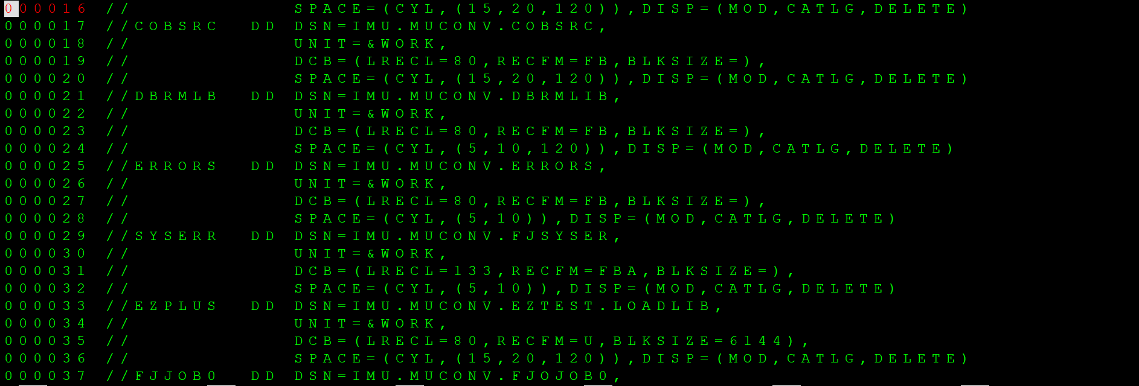

Figure 59: Changing all of the “???????” into “IMU”.

**Step 45: In the same dataset “IMU.SFSYJCLS” look into the member “JCMUCL1J” member, then check library at line 0004.**



Figure 60: Checking member library of member “JCMUCL1J”.

**Step 46: In the same dataset and member, at line 0022, change the “???????” into “IMU”**



Figure 61: Changing the “???????” into “IMU”.

**Step 47: In the same dataset and member, at line 0031, ensure the “???????” has been changed to “IMU”.**



Figure 62: Changing the module location to “IMU”.

**Step 48: After changing everything in the member “JCMUCL1J”, submit the job.**



Figure 63: Submitting the “JCMUCL1J” member.